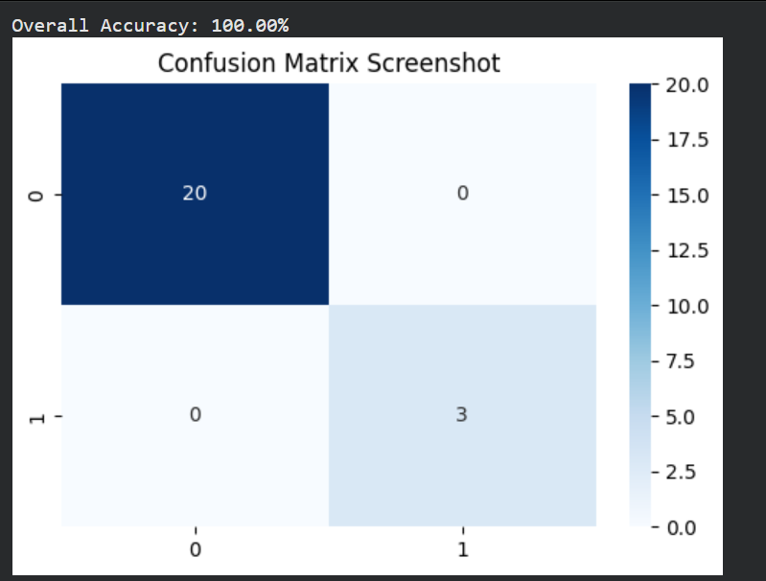
• Model: XGBoost Classifier
• Test Samples: 23 total (20 Safe, 3 Flood)
• Accuracy: 100%
• Result: The model successfully identified all flood risks and safe conditions without any False Positives or False Negatives.
Why XGBoost won:
- Gradient Boosting: It builds trees sequentially, where each new tree corrects the errors of the previous ones.
- Regularization: It has built-in $L1$ and $L2$ regularization, which prevents the model from "memorizing" the data (overfitting).
- Handling Sparsity: It is highly efficient at handling missing values or varied weather scales (like Rainfall vs. Temperature).

